**Manager Table**

* **Create Query:**

**Create table of name “MANAGER” having attributes ID (PK), MNAME for manager name, HNAME for assigned hall of that manager, SALARY and HIREDATE.**

CREATE TABLE MANAGER

( ID NUMBER(4) PRIMARY KEY ,

MNAME VARCHAR2(20),

HNAME VARCHAR2(20),

SALARY NUMBER(7,2),

HIREDATE DATE );

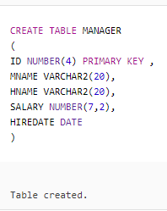

* **Insert Queries:**

INSERT INTO MANAGER VALUES

(5001,'SOHAIL RANA', 'AL-JANNAT',50000,TO_DATE('17-DEC-2015','DD-MON-YYYY'));

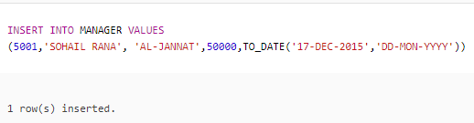

INSERT INTO MANAGER VALUES

(5002,'ABDUL REHMAN', 'DEWAN-E-KHAAS',45000,TO_DATE('21-JAN-2017',

'DD-MON-YYYY'));

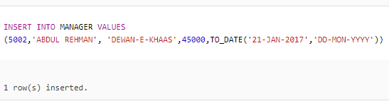

INSERT INTO MANAGER VALUES

(5003,'OMER ARSHAD', 'MUSKAN',48000,TO_DATE('12-SEP-2015','DD-MON-YYYY'));

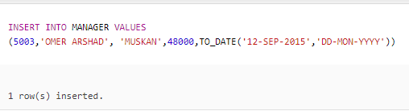

INSERT INTO MANAGER VALUES

(5004,'SAIM JAMEEL', 'SHALAMAR CASTLE',50000,TO_DATE('25-FEB-2016','DD-MON-YYYY'));

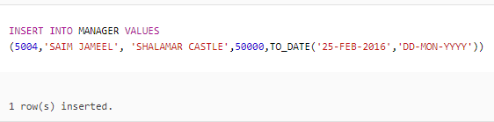

INSERT INTO MANAGER VALUES

(5005,'TANVEER ANJUM', 'TAJ MAHAL',65000,TO_DATE('11-APR-2017','DD-MON-YYYY'));

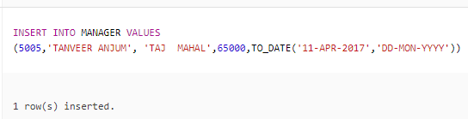

INSERT INTO MANAGER VALUES

(5006,'SOHAIL SADIQ', 'LAHORE CASTLE',52500,TO_DATE('6-OCT-2017','DD-MON-YYYY'));

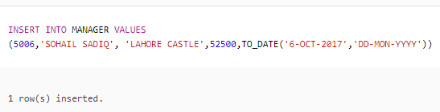

INSERT INTO MANAGER VALUES

(5007,'ABDUL REHMAN', 'MUGHAL-E-AZAM',70000,TO_DATE('1-MAY-2017','DD-MON-YYYY'));

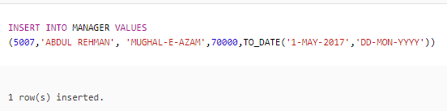

* **Delete Queries:**



**Delete all the records of row having ID 5008.**

DELETE FROM MANAGER

WHERE ID = 5008;

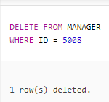



**Delete all the records of row having ID 5009.**

DELETE FROM MANAGER

WHERE ID = 5009;

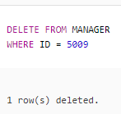



**Delete all the records of row having ID 5010.**

DELETE FROM MANAGER

WHERE ID = 5010;

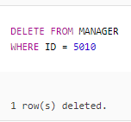



**Delete all the records of row having ID 5011.**

DELETE FROM MANAGER

WHERE ID = 5011;

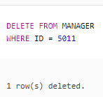



**Delete all the records of row having ID 5012.**

DELETE FROM MANAGER

WHERE ID = 5012;

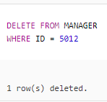

* **Update Queries:**



**Change the name of manager having ID 5003 as “REHAN ASHRAF”. He is the manager of QASAR-E-NOOR and his salary is 66900.**

UPDATE MANAGER

SET MNAME = 'REHAN ASHRAF', HNAME = 'QASAR-E-NOOR', SALARY = 66900

WHERE ID = 5003;

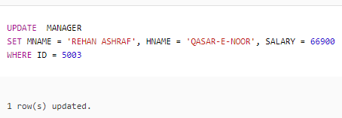



**Change the name of manager having ID 5004 as “YASIR SADEEQ”. He is the manager of GARDENIA and his salary is 60000.**

UPDATE MANAGER

SET MNAME = 'YASIR SADEEQ', HNAME = 'GARDENIA', SALARY = 60000

WHERE ID = 5004;

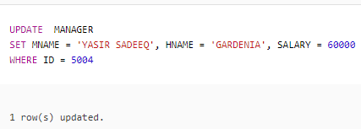



**Salary of Manager having ID 5006 is increased. His new salary is 55000. Update his salary.**

UPDATE MANAGER

SET SALARY = 55000

WHERE ID = 5006;

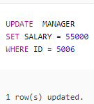



**Manager having ID 5005 is changed. USMAN AKBER is new manager and his ID is 5010. Update ID and Manager Name.**

UPDATE MANAGER

SET ID = 5010, MNAME = 'USMAN AKBER'

WHERE ID = 5005;

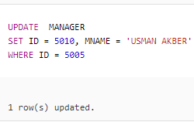



**Manager having ID 5001 is resigned and KOMAL BUTT is appointed as new manager. Update the manager name.**

UPDATE MANAGER

SET MNAME = 'KOMAL BUTT'

WHERE ID = 5001;

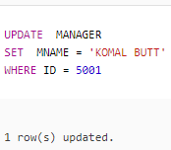

* **Other Queries:**

**Display manager name and hall name.**

SELECT MNAME, HNAME

FROM MANAGER;

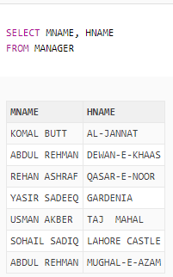

1. **Display name of those managers whose salary is greater than 50000 and working in DEWAN-E-KHAAS or TAJ MAHAL.**

SELECT MNAME

FROM MANAGER

WHERE SALARY > 50000

AND HNAME IN (‘DEWAN-E-KHAAS’, ‘TAJ MAHAL’);

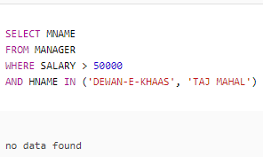

1. **Give manager names and their annual salary as “ANNUAL SALARY”.**

SELECT MNAME, SALARY*12 “ANNUAL SALARY”

FROM MANAGER;

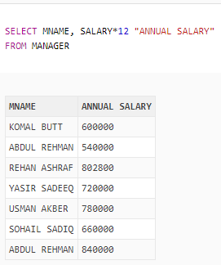

1. **Give name and salary of those managers who work in DEWAN-E-KHAAS.**

SELECT MNAME, SALARY

FROM MANAGER

WHERE HNAME = ‘DEWAN-E-KHAAS’;

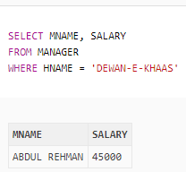

1. **Display name and hire date of manager who hired after 1-JAN-2016.**

SELECT MNAME, HIREDATE

FROM MANAGER

WHERE HIREDATE > ‘1-JAN-2016’;

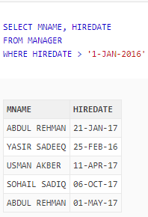

1. **Display complete record of manager whose salary is between 50000 and 70000.**

SELECT *

FROM MANAGER

WHERE SALARY BETWEEN 50000 AND 70000;

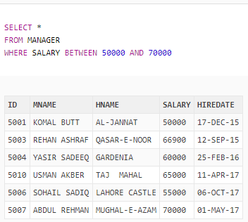

1. **Show id as “MANAGER ID” , hire date as “HIRING DATE” of all managers in order by ID.**

SELECT ID “MANAGER ID”, HIREDATE “HIRING DATE”

FROM MANAGER

ORDER BY ID;

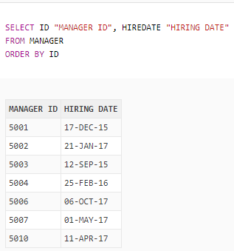

1. **Give name, salary and hire date of those managers who have 2nd letter “A” in their name.**

SELECT MNAME, SALARY, HIREDATE

FROM MANAGER

WHERE MNAME LIKE ‘_A%’;

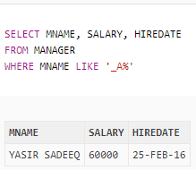

1. **Show id, salary, 12% of salary as “TAX” and salary after tax deduction as “SALARY AFTER TAX DEDUCTION” of all managers, display output in order by tax.**

SELECT ID, SALARY, (SALARY*0.12) “TAX”, SALARY – (SALARY*0.12) “SALARY AFTER TAX DEDUCTION”

FROM MANAGER

ORDER BY TAX;

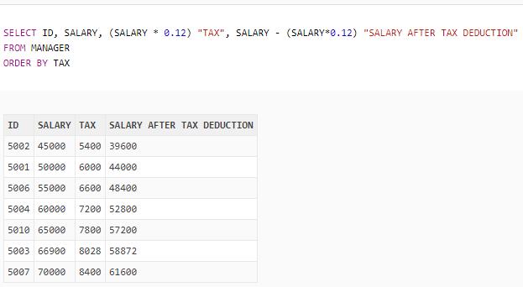

1. **Show id, name, hire date and 1st Monday after hiring as “1st MONDAY” of all managers.**

SELECT ID, MNAME, HIREDATE, NEXT_DAY(HIREDATE, ‘MONDAY’) “1ST MONDAY”

FROM MANAGER;

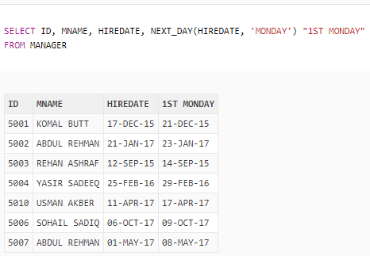

1. **Show salary and name of managers as “SALARY OF KOMAL BUTT IS 50000” as “SALARY”.**

SELECT ‘SALARY OF ‘ || MNAME || ‘ IS ‘ || SALARY “SALARY”

FROM MANAGER;

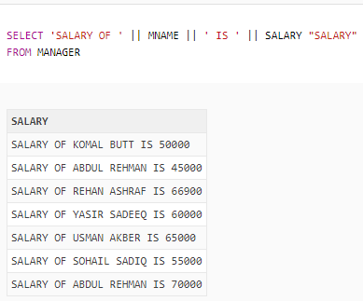

1. **Display id and name of all those managers who have id less than 5006.**

SELECT ID, MNAME

FROM MANAGER

WHERE ID < 5006;

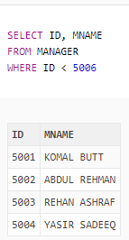

1. **Show name of manager whose salary is greater than 50000.**

SELECT MNAME

FROM MANAGER

WHERE SALARY > 50000;

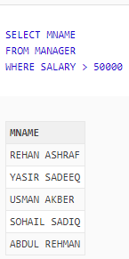

1. **Display name and annual salary as “ANNUAL SALARY” of all those managers who hired on 19-DEC-2015.**

SELECT MNAME, SALARY*12 “ANNUAL SALARY”

FROM MANAGER

WHERE HIREDARE = ’19-DEC-2015’;

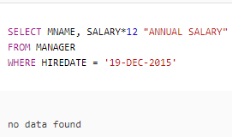

1. **Display name and hire date in format “DAY MONTH YYYY” as “HIREDATE of all managers.**

SELECT MNAME, TO_CHAR (HIREDATE, ‘FMDAY MONTH YYYY’) “HIREDATE”

FROM MANAGER;

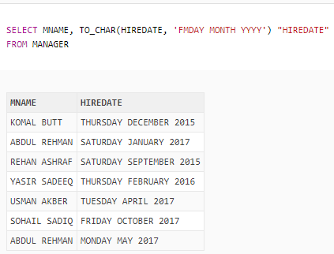

* **Function Queries:**

**Display manager name in reverse order as “REVERSE NAME”.**

SELECT REVERSE (MNAME) “REVERSE NAME”

FROM MANAGER;

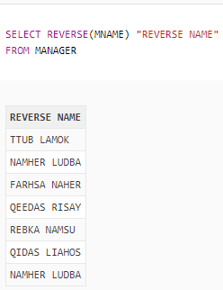

**Show last 4 letters of manager’s name as “LAST 4 LETTER”.**

SELECT SUBSTR (MNAME, LENGTH(MNAME) - 3, 4) “LAST 4 LETTERS”

FROM MANAGER;

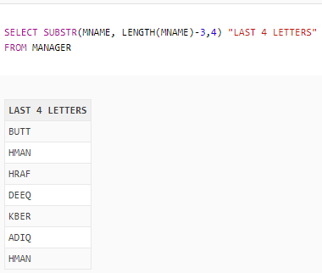

**Display salary in terms of “$”where each $ represents 1000.**

SELECT LPAD (‘ ‘, SALARY/1000+1, ‘$’) “SALARY”

FROM MANAGER;

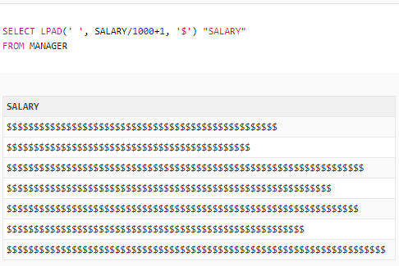

* **Sub-Queries:**

**Display id and name of those managers whose salary is greater than the salary of those managers who have double A in name as name end with A.**

SELECT REVERSE (MNAME) “REVERSE NAME”

FROM MANAGER;

SELECT ID, MNAME

FROM MANAGER

WHERE SALARY > ANY (SELECT SALARY

FROM MANAGER

WHERE MNAME LIKE ‘%A%A’);

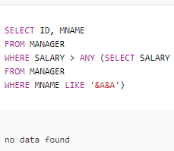

**Show name, id and salary of all those managers whose salary is greater than the salary of those managers who have id 5002.**

SELECT MNAME, ID, SALARY

FROM MANAGER

WHERE SALARY > (SELECT SALARY

FROM MANAGER

WHERE ID = 5002);

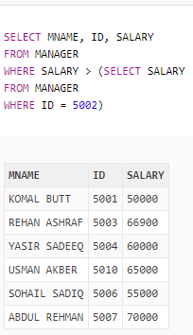

**Give id, name, salary and hire date of those manager who hired after USMAN AKBER and getting salary greater than the salary of SOHAIL SADIQ.**

SELECT ID, MNAME, SALARY, HIREDATE

FROM MANAGER

WHERE HIREDATE > ALL (SELECT HIREDATE

FROM MANAGER

WHERE MNAME = ‘USMAN AKKBER’)

AND SALARY > ALL (SELECT SALARY

FROM MANAGER

WHERE MNAME = ‘SOHAIL SADIQ’);

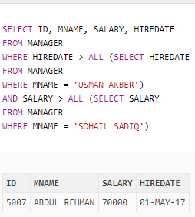

**Table**

